Dominic Drury

09/23/2024

CS-470

4-4 Assignment: Testing Lambda and Gateway API

Screenshot of the GET method execution page

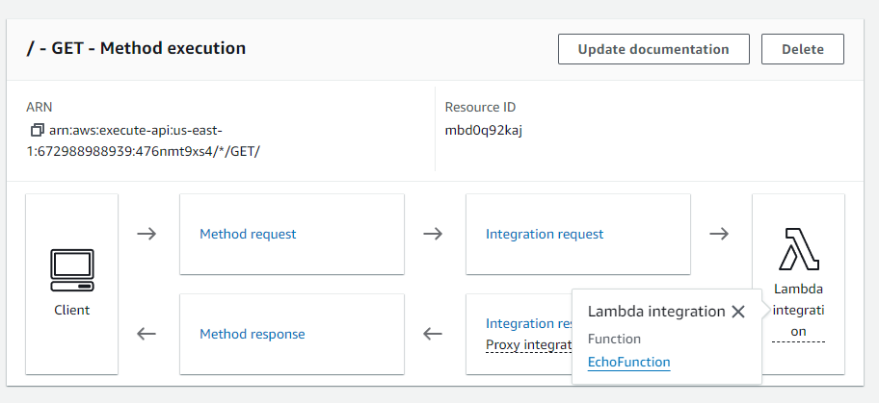

Screenshot of the GET test page

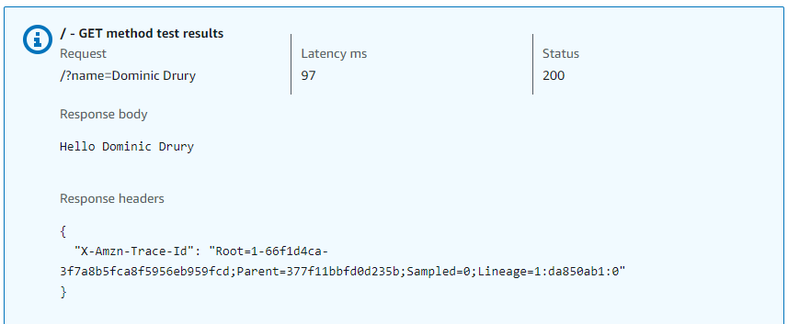

Screenshot of the browser running the URL

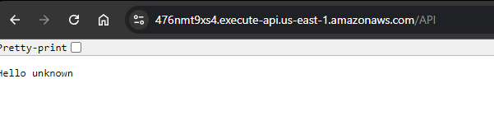

The invoke URL from your deployment

